Demonstration Review
  - LS Academy
Table of Contents

Administrator
The following is a list of software feature concerns I have for the administrative area.

Dashboard
No direct concerns.
I would change the html class on each to class=”col-lg-2 col-xs-6” – some image resizing might be needed.

Configuration
No direct concerns.

Instructors
Why can I edit an instructor's profile but not their courses?
How can I see a list of all courses an instructor has uploaded?
If this were a requirement, I would say something like this:
1. Create a hyperlink for each username in the Manage Instructors list. When this hyperlink is clicked, it should redirect the user to the “Manage Courses” tab and search for—or filter—all courses by this instructor)
2. Add a Date Range filter.
3. Add a column called, “Payments” that shows a summary ($ total) of all of the payments the instructor received within that date range. Each entry is a hyperlink. When clicked, a modal details window should show Course Name, Instructor Payments for that course ($ total), Student Orders (this is a count not a $ total), and Marketplace Commission ($ total). This should be printable as a report (so a “print” button would be need).

Students
Why can I edit a student's profile but cannot see what courses they have purchased?
If this were a requirement, I would say something like this:
Create a hyperlink for each username in the Manage Students list. When this hyperlink is clicked, it should redirect the user to the “View Orders” tab and search for—or filter—all Orders for this Student Name. This should be order by date descending.

Orders
There should be a column, to the left of "Student Name" that displays the "Instructor" (name)
If this were a requirement, I would say something like this:
1. There should be a column, to the right of Order ID called, “Payments” that states whether the order was "PAID" (or “Completed” or whatever you decide). This should be hyperlinked. If the user clicks on the PAID hyperlink the user should be redirected to the Payments tab and the page should search for—or filter—the exact Order ID and show the result.
2. There should be a column to the left of the Student Name called, “Instructor” that is hyperlinked. When this hyperlink is clicked, it should show the same page again but search for—or filter—all students who have created an order (by this instructor). The “Clear Search” should work as well returning the original unfiltered view. This will allow the admin to support a customer by understanding who her/his paying students are.

Payments
Why can’t I search for payment history by [Date] or by [Transaction ID]?
If this were a requirement, I would say something like this:
1. Create a Radio Button Group that includes [Keyword, Date, Order ID, Transaction ID] and allow the search to filter on one of these. The Keyword filter is a LIKE search by Student Name or Amount and is the default setting (not Transaction ID).
2. Rename the column, Payment For Order -> Order ID
3. Hyperlink each Order ID. When clicked, it should redirect the user to the Orders tab and search for—or filter—the order by and show that Student’s details.
4. In the left-hand navigation I would move Payments BELOW Orders (I’ll address later)

Courses
Why can’t I click on a course title and be able to view, edit that course?
If this were a requirement, I would say something like this:
1. Add a  button to the left of the Active/Inactive button. When clicked, I should be redirected a page that allows me to impersonate and edit the course with all of the same capabilities as the instructor. How can I provide support to an instructor if I cannot even see what is in their course?
(this page should already exist on the front-end; it should be duplicated and available in admin; and the user information (when data is saved) should use the instructor’s credential). This page should, of course, only be accessible to an admin.
2. Hyperlink each Instructor. If this hyperlink is clicked it should show the same page again by only show the courses by that instructor. I would need to know what courses a particular instructor has created.

Categories
I would expect to see a summary total of all courses underneath this category.
If this were a requirement, I would say something like this:
1. If the Engineering category has:
- “Mechanical Engineering” (5)
- “Electrical Engineering” (5)
- “Civil Engineering” (5)
Then the Top-level category, should be “Engineering (15)” – did I explain this correctly?
2. The Date should be the most-recent date any courses were added to that category
This would help the admin easily determine where to create a Sale for a particular category.

Countries
No direct concerns.

Testimonials
No direct concerns.

Pages
No direct concerns.

Left Hand Navigation
The menu names and order should change.
If this were a requirement, I would say something like this:
1. Please remove the words, “Manage” and View” from the left-hand navigation.
2. Please reorder the tabs as follows for a more logical admin experience:
- Dashboard
- Reports
- Instructors
- Courses
- Students
- Orders
- Payments
- Testimonials
- Categories
- Countries
- Pages
- Configuration

Instructor
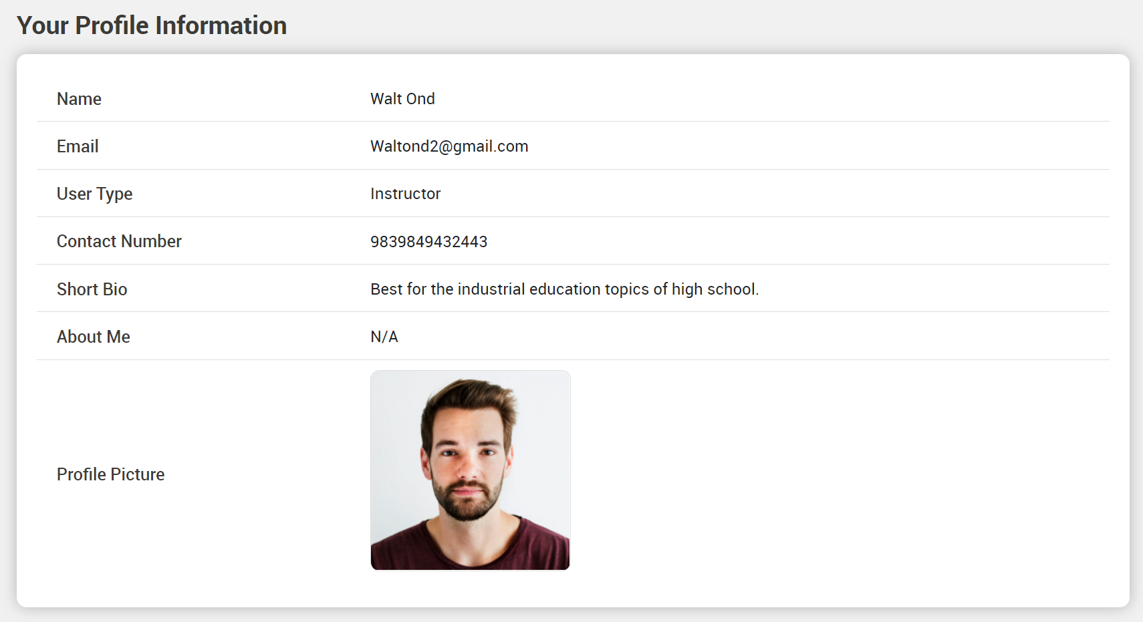
I cannot evaluate this capability
At a minimum, I need to see how I can:
- Manage my Instructor Profile
- Manage my Payment Settings
(how the exchange sends me money once a student orders a course)
- I should have a message system (Inbox; see requirement under Students)
- I need to be able send an email through the website to:
  - A single student
  - All students for one of my courses
  - All students for all courses
- I need to be able create a course
  - Overview
    - Description
    - About this course
    - Skill level
    - Language
    - Lectures
    - Certificate
  - Create Sections
  - Define Lectures for that section
    - Title
    - Upload the Video
    - If I upload a document or audio then this becomes a “resource” for that lecture.
    - Preview my course (see what the Student sees)
- Manage and Answer Q&A (removing posts)
- Create an Announcement (in the course; the same as “send email”)
- The ability to provide responses to individual reviews as the instructor.
I must be able to see this in order to make a purchase decision.

The Video Player is not adequate and needs to be MORE like UDEMY.

Student
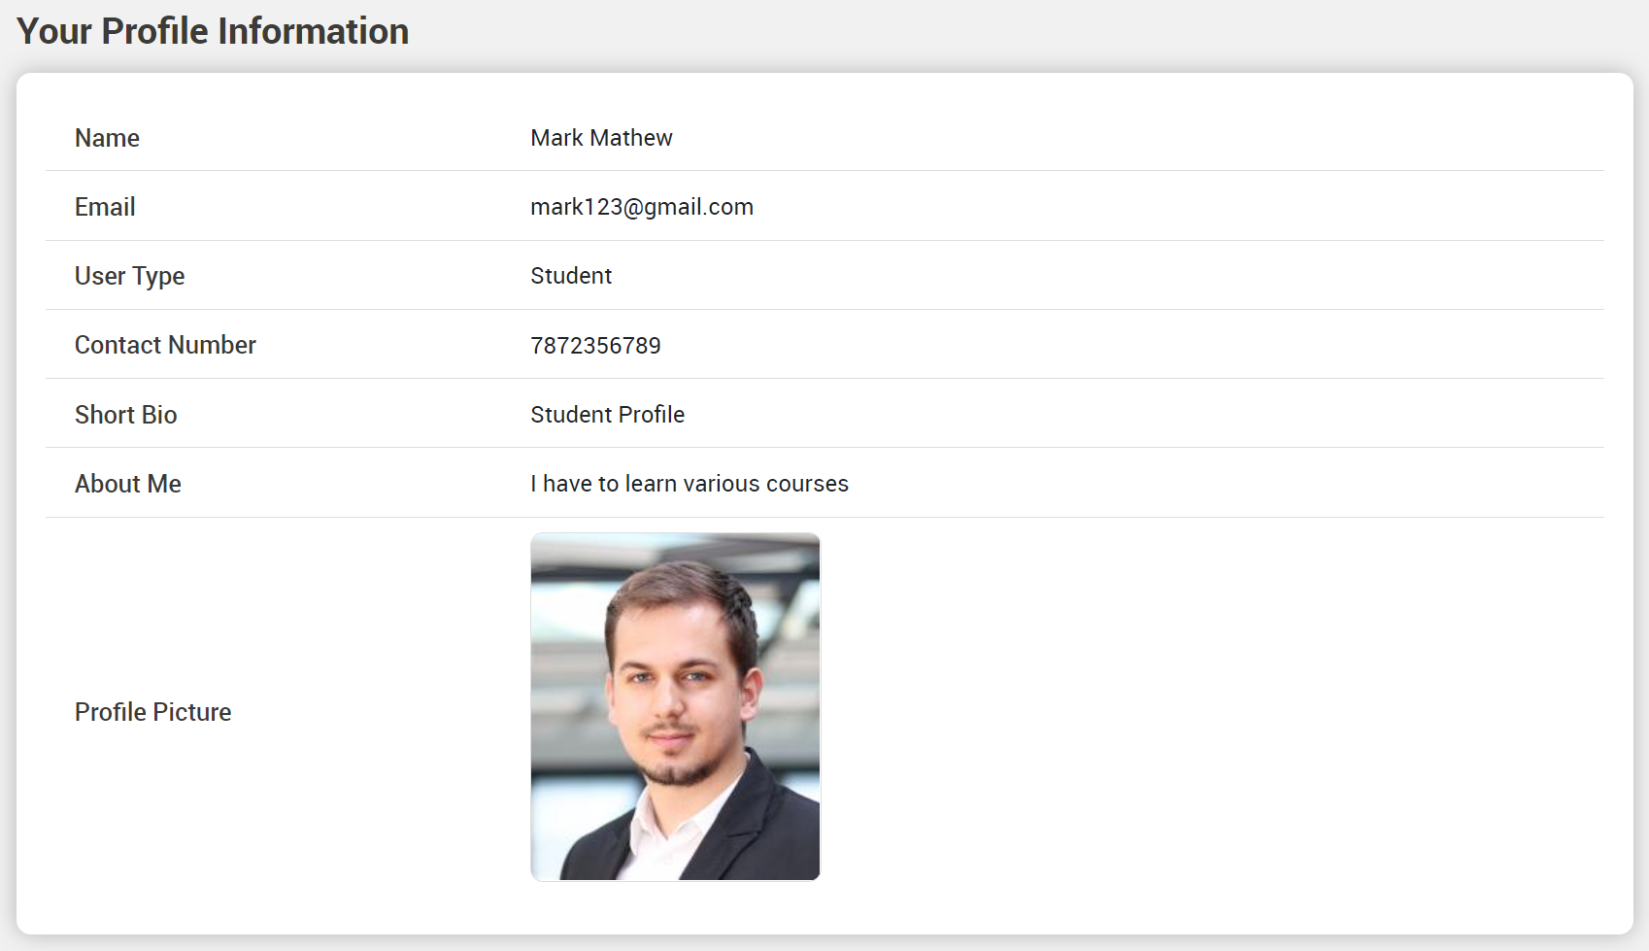I cannot evaluate this capability
At a minimum, I need to also see:
- My Courses (I need to be able to archive a course; does not actually delete but no longer visible or accessible to the student unless the student switches to “archive” list)
- My Order History
- My Reviews (by course)
- My Certificates
- My Payment Settings (so I can pay)
Also, there should be a message system (communication is key to learning)
Inbox
- Messages from Instructor should be different than other messages.
- Should have a [Create Message], [Reply], [Create Folder], [Move to Folder], [Delete] etc.

