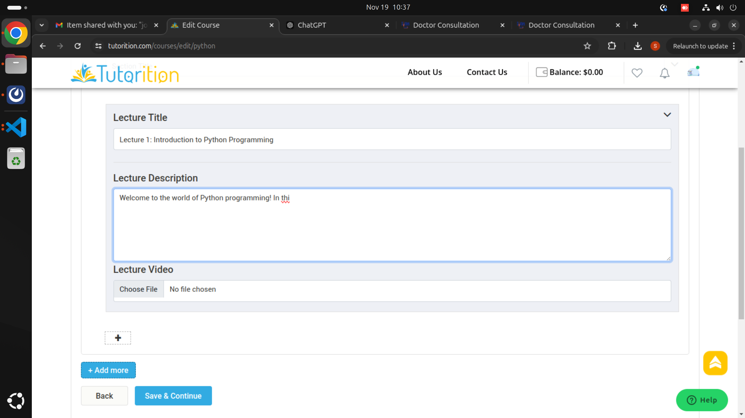
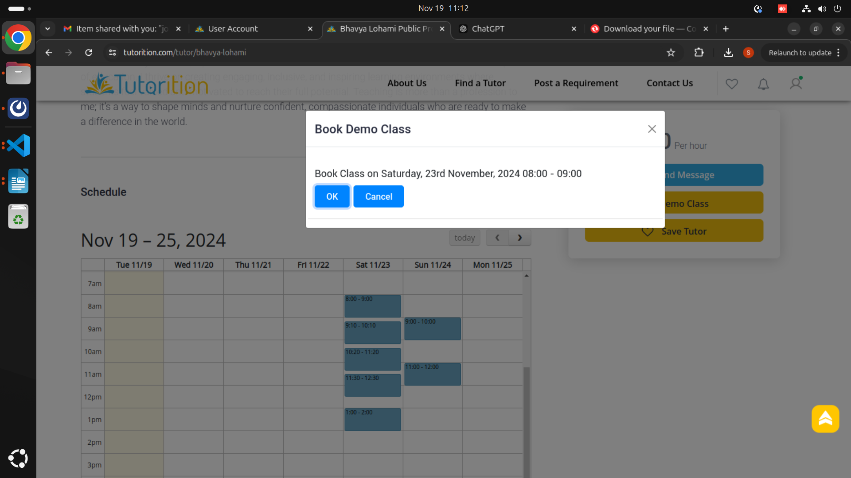
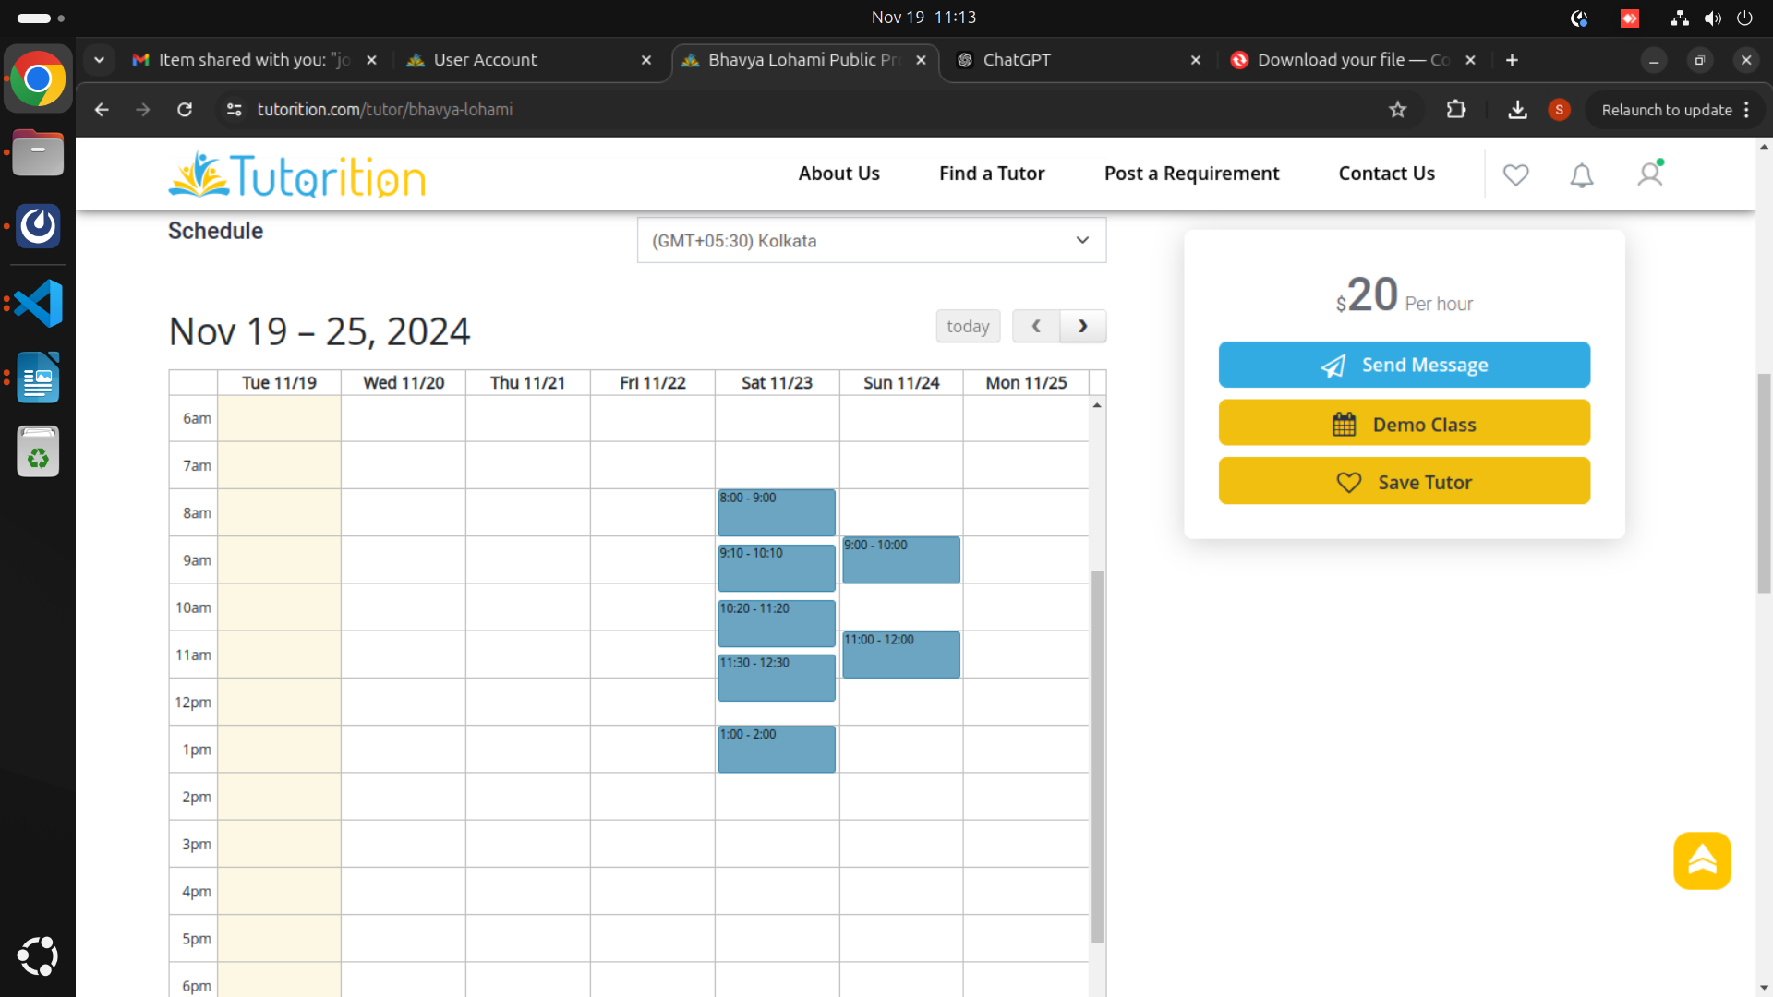
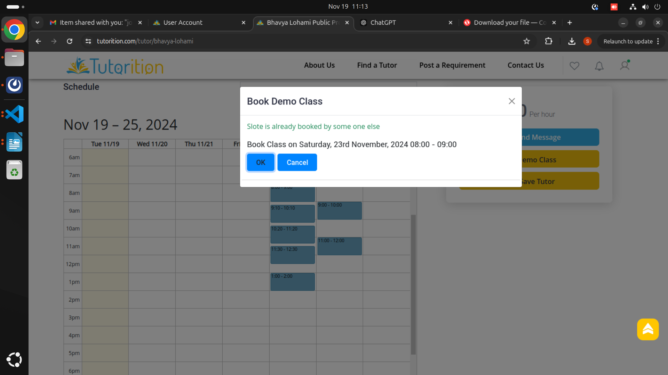
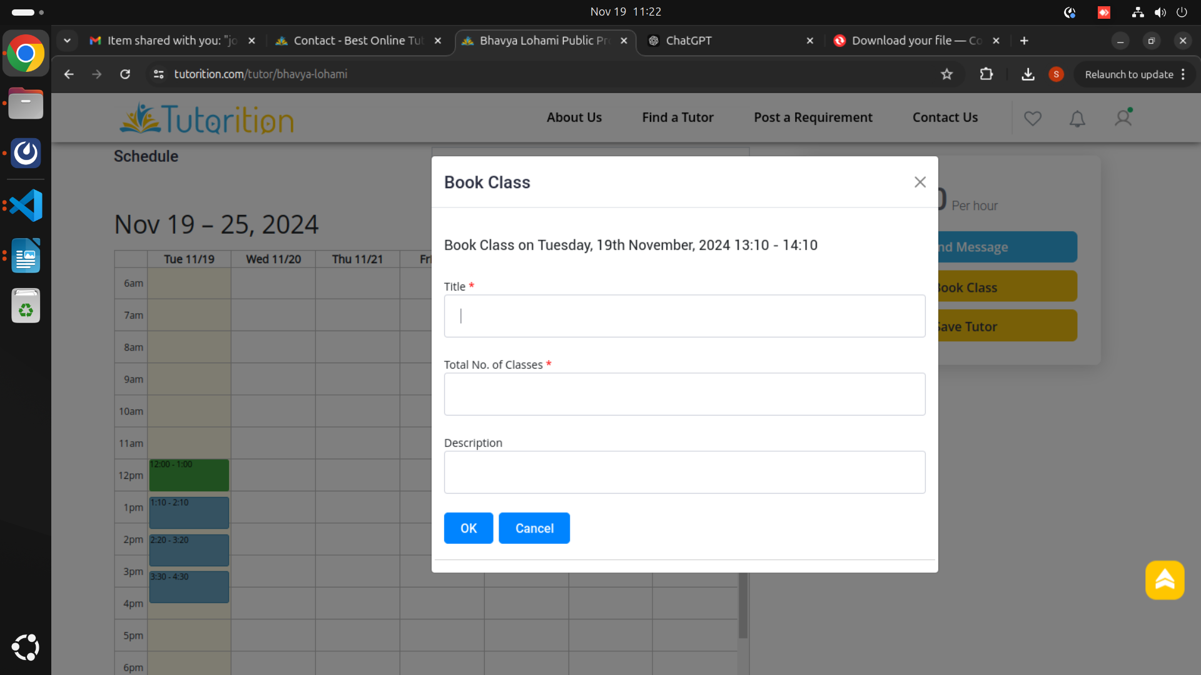
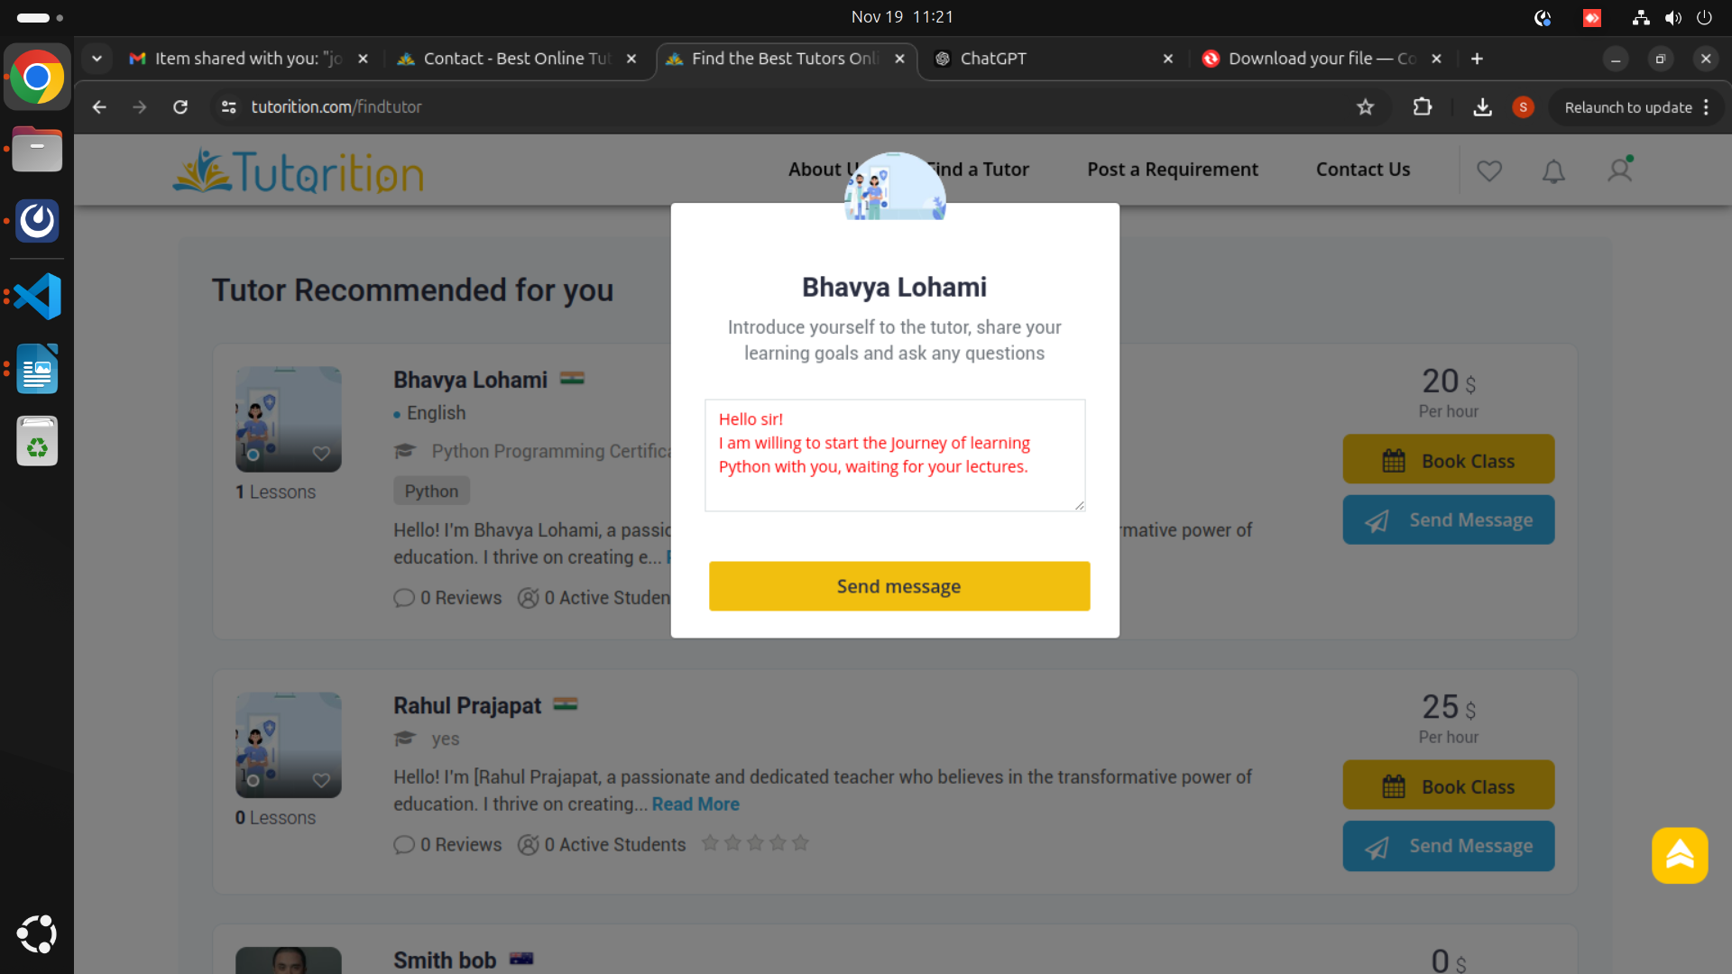
Tutorition

Url : https://blog.tutorition.com/effective-study-habits-for-language-learners-tips- from-online-tutors
Description: In this section at the top of the Blog Page Warnings are displayed before the blog content is displayed and similarly for the dedicated single(Particular) blog page is happening. and also after login in header asking for login.
Image:
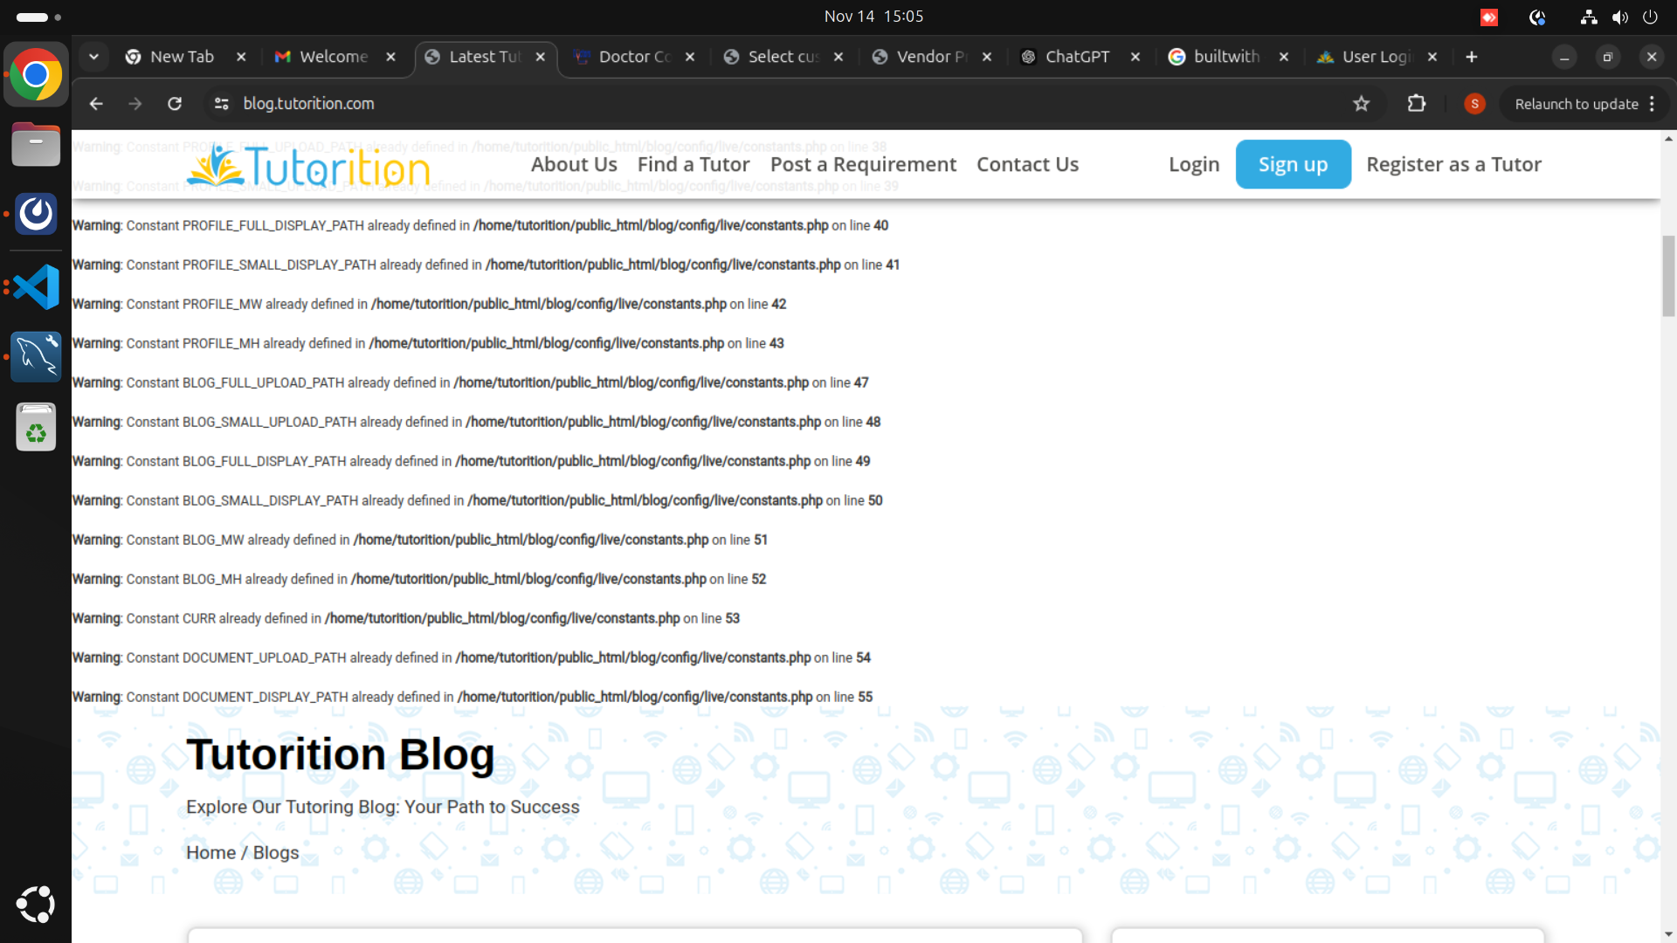
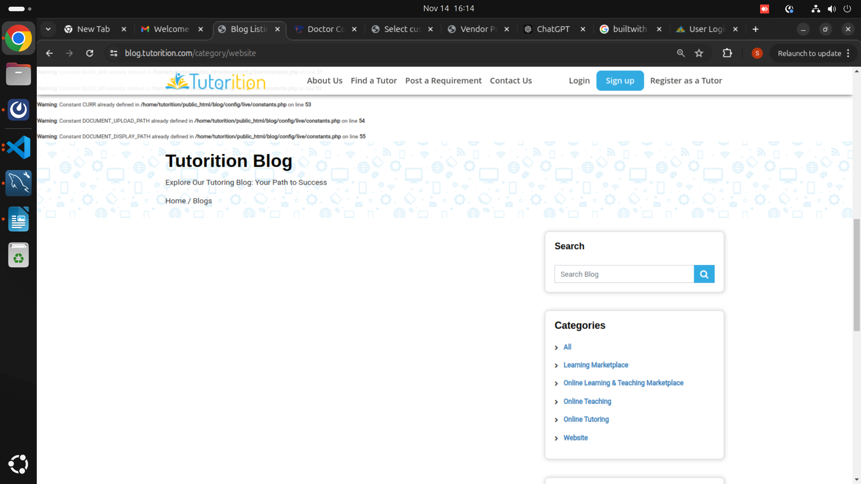
Url : https://blog.tutorition.com/category/website
Description: Does not getting any result or message on this url.
Image:
Url : https://tutorition.com/my-classes
Description: After Booking a Demo class on find a tutor didn’t receive any notification and when on moving to my classes section in my profile got the below mentioned image. And can’t see the information of the demo class which I have booked.
Image:
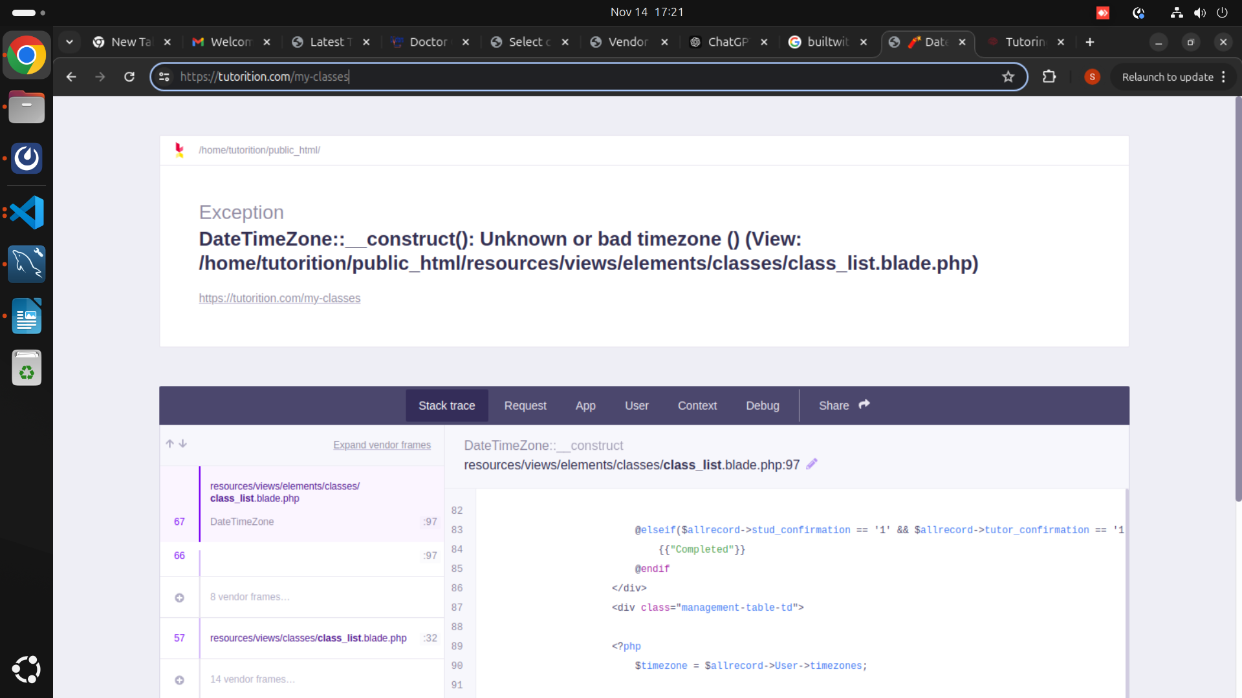
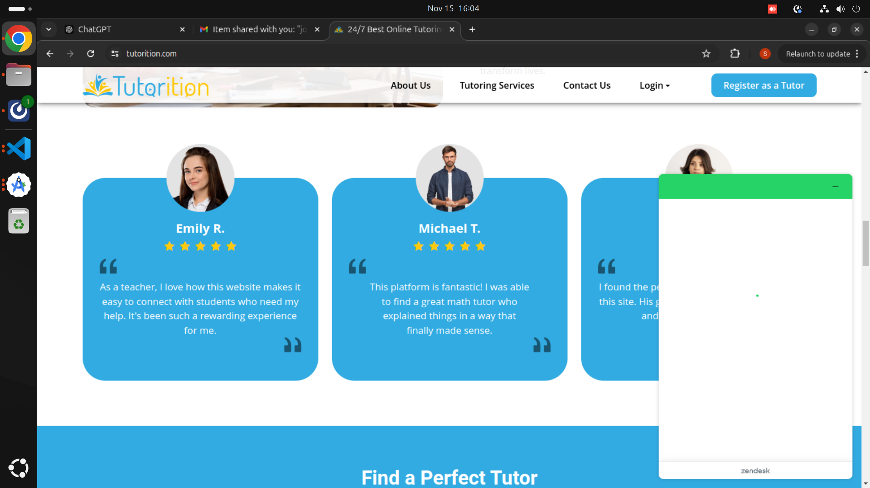
Url : https://tutorition.com
Description: Chat-bot is not working.
Image:
Url : https://tutorition.com/tutor/sss-e6b6e2d12b0d#week_calendar
Description: While Booking a demo if the slots are not available then also in calender the slots are clickable which is confusing as after clicking the time appears and selected but nothing happening afterward.
So it will be confusing to the new user and will give bad user experience.
Image:
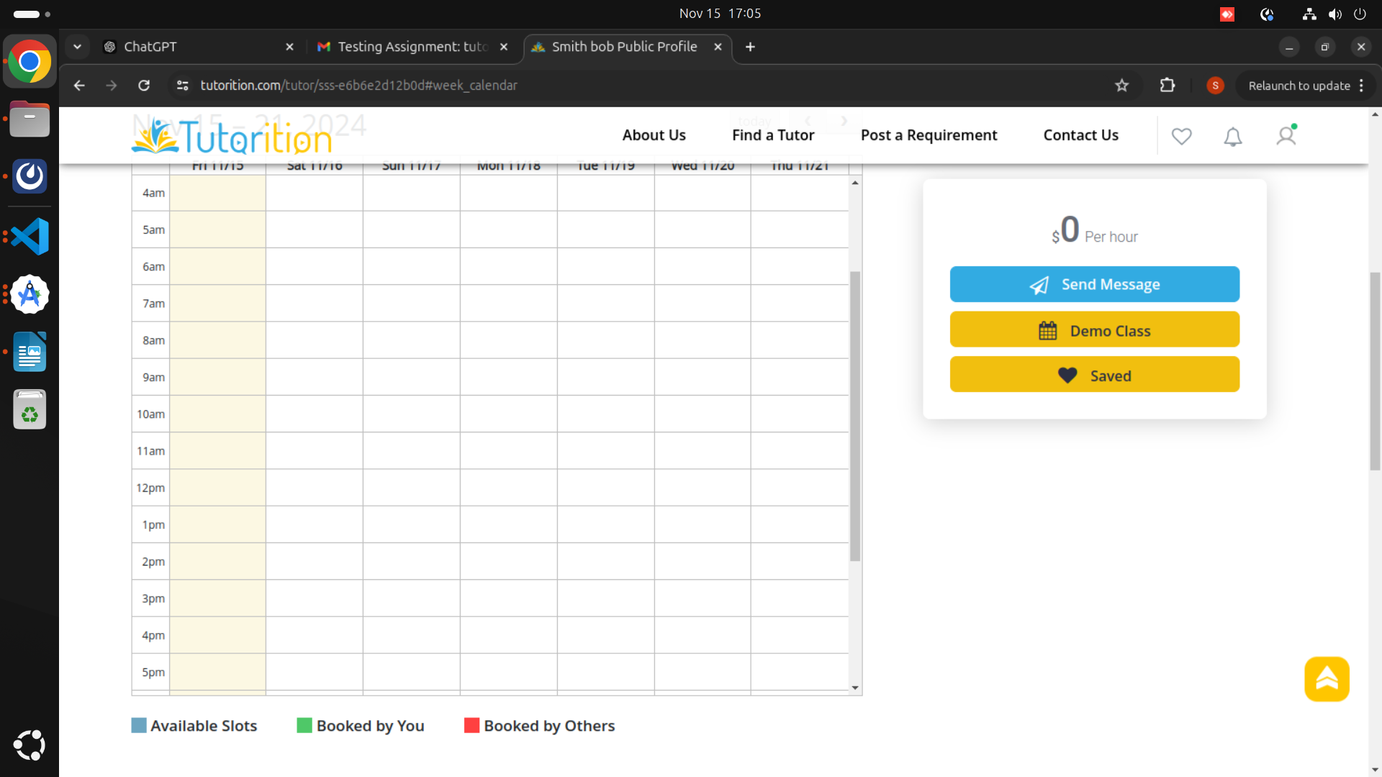
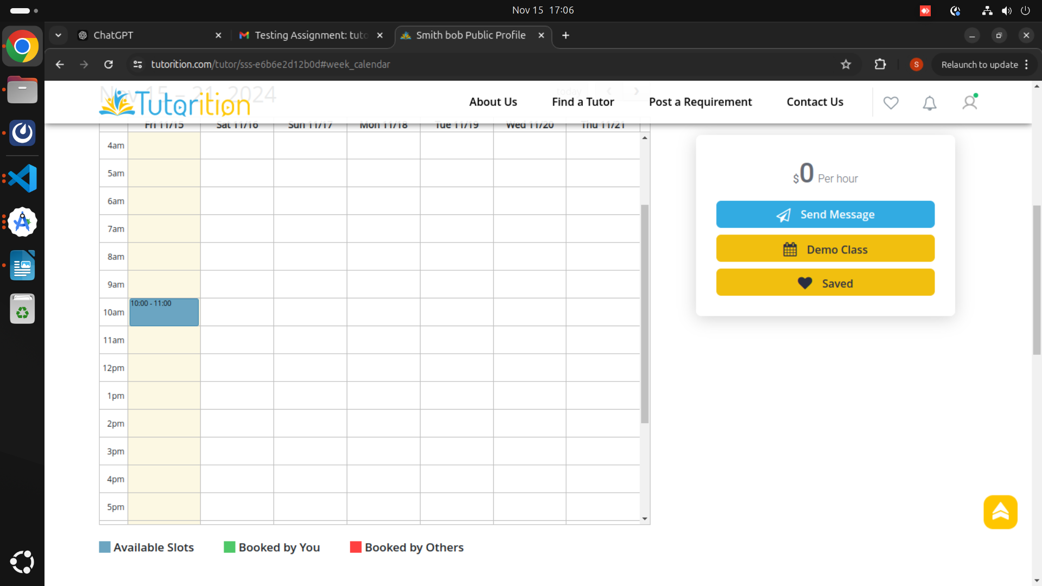
Url : https://tutorition.com/teacher-signup
Description:
In the Certification Section some fields naming are confusing.
1.certificate field – what the user has to mention (yes / no) or what ?
2. years of study.
3. in the years of study field – dropdown has not the updated values of years.
In the Education Section
1. similar problem of drop-down.
In the Availability section
1. manually adding slots for each day is very time consuming and after adding each slot it process which consumes more time and giving bad experience.
Image:
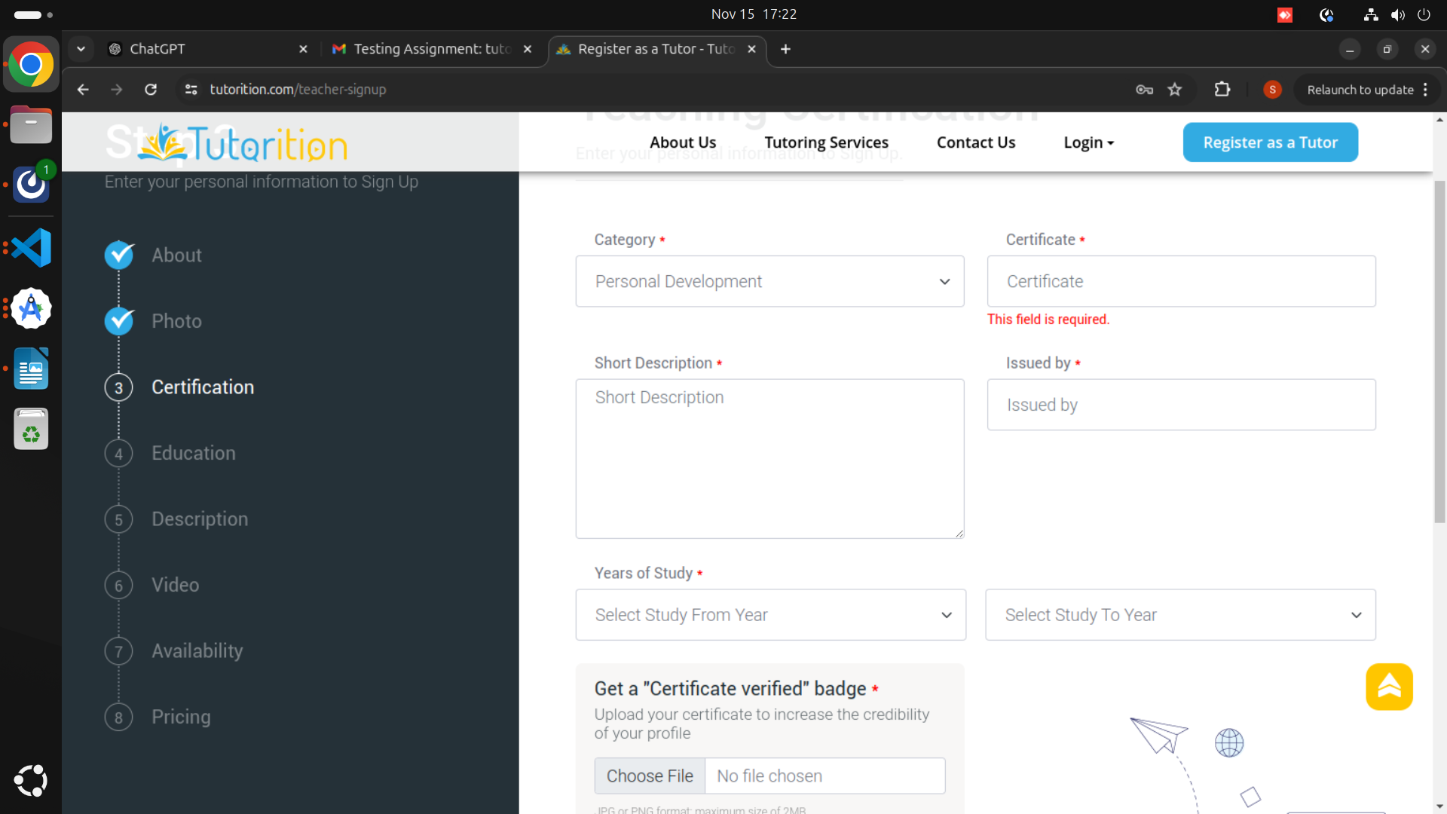
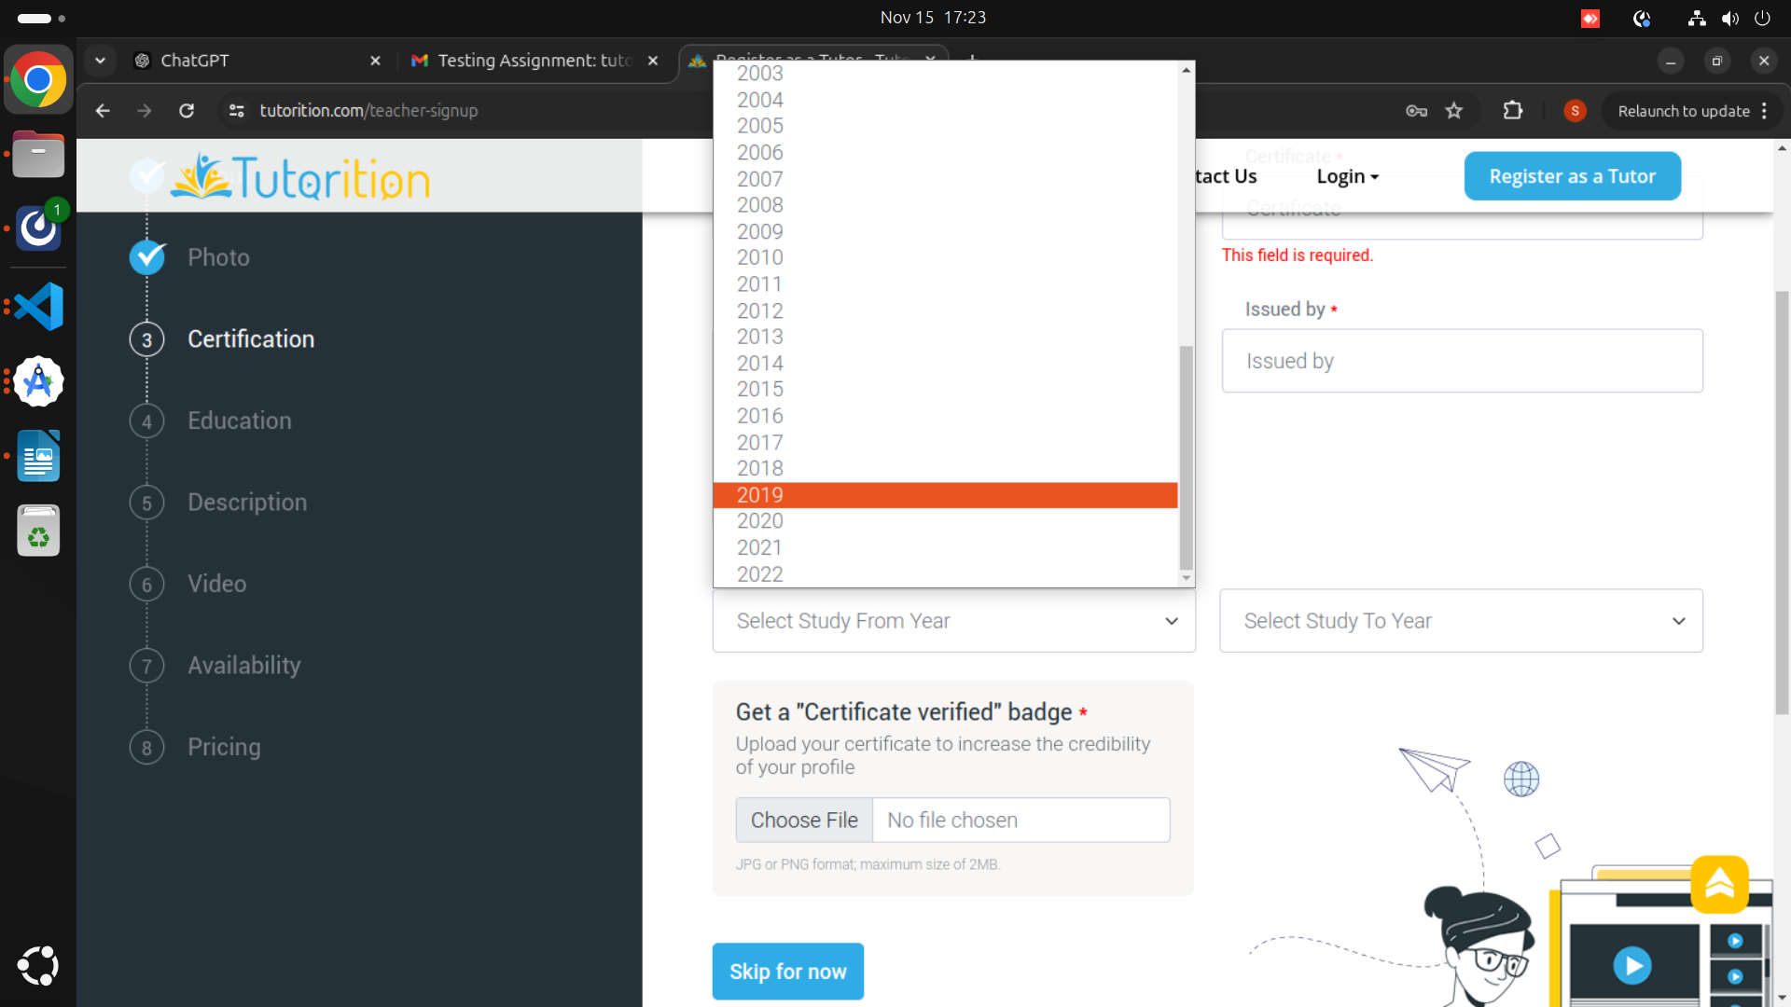
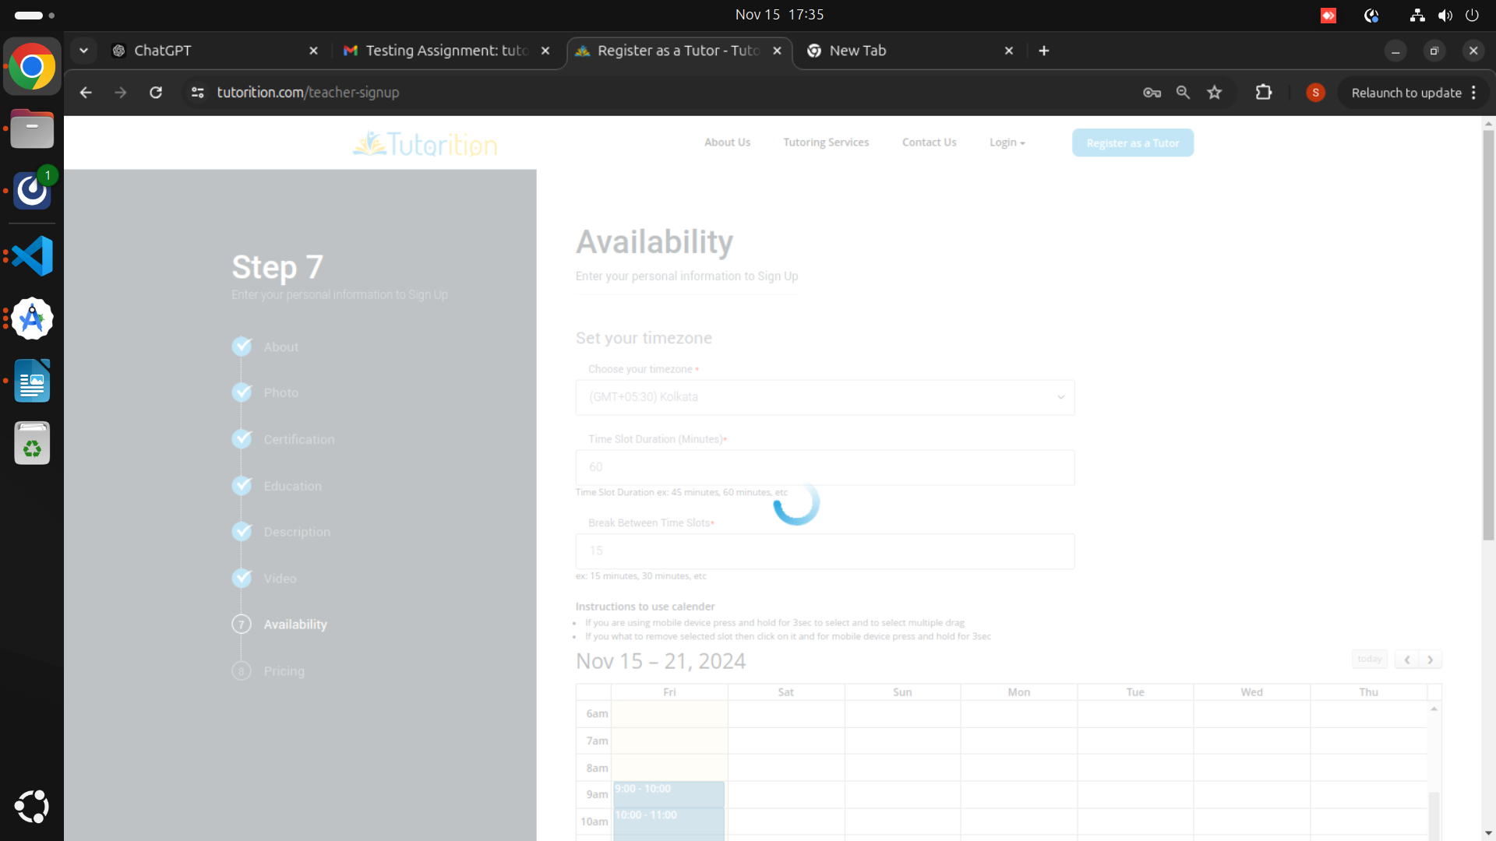
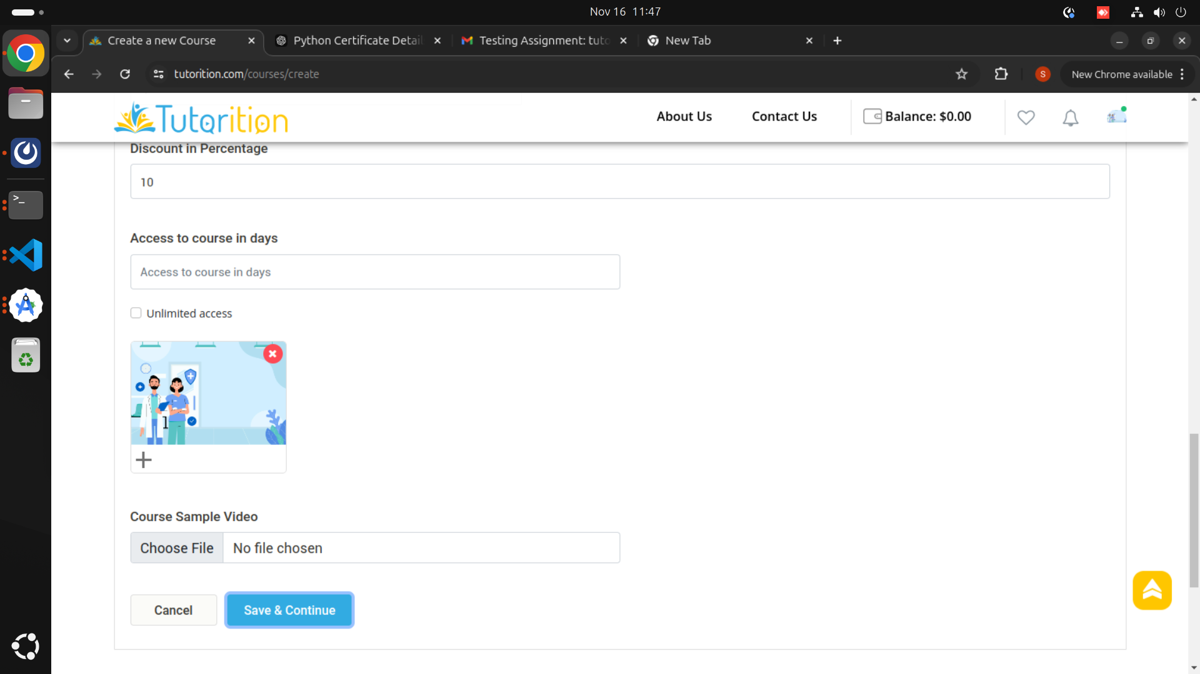
Url : https://tutorition.com/courses/create
Description: In this section when the image is uploaded then also it is giving the error “ The Image field is required” and in the field sub-category drop-down I didn’t get any value to select and when going to submit getting errors.
Image:
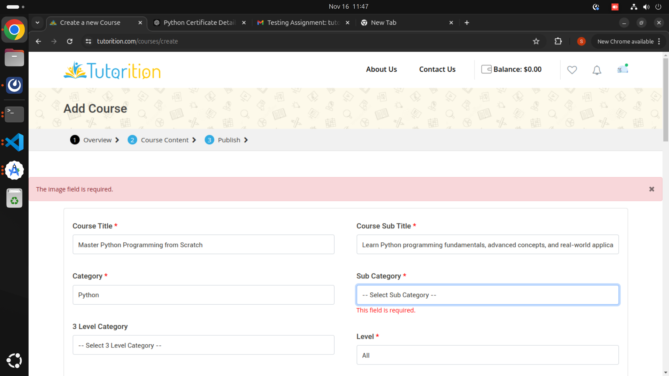
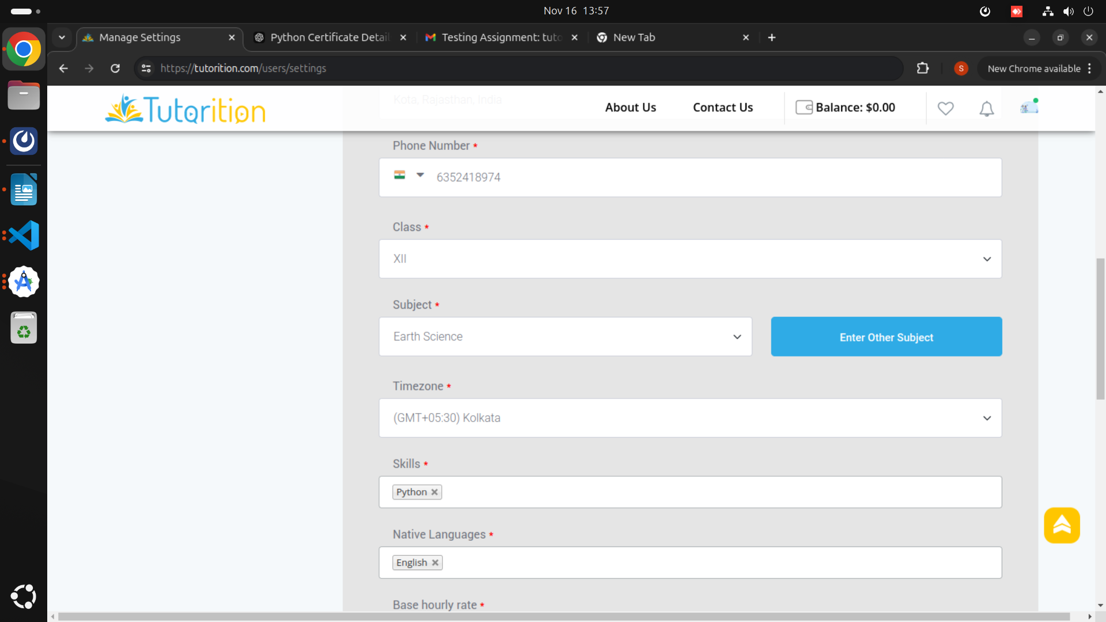
Url : https://tutorition.com/users/settings
Description: At this section in the Subject Field there is an option to enter another subject but can’t be able to add another subject.
Image:
URL : https://tutorition.com/courses/edit/python
Description: In this Section in Lecture Description field not able to enter the Description. Increase the word limit.
Image:

URL : https://tutorition.com/tutor/bhavya-lohami
Description: In this section when the student book a demo class, after clicking the OK button there is no confirmation message and it is displayed the same, creating the confusion to the student weather the class is booked or not and also the slot color is not changes until it is again visited for booking.
Image:

URL : https://tutorition.com/findtutor
Description: After sending the message the message box does not get empty, it contains the previous message or either it should get close.
Image:
URL : https://tutorition.com/findtutor
Description: After the Demo class if the student book the class this pop up appears
doesn’t get the purpose of this, there is no guidance for this process to the student what he/she have to mention in this or the title field should be auto-filled or should give the drop down to select the class form the courses launched by the tutor and there is no means of selecting the no. of classes as only one slot is selected and also the amount in the final bill is coming of only one hour after selecting more than one class.

