Steps to solve the problem of 5xx error that arrises in Nextjs while sending indexing request.

First, let us understand why this issue arises:
When we send the indexing request to google for any routes of our project after we upload a Nextjs website or any website on the server, google sends its crawlers to check the routes and index them. So in case the crawlers face any server error (500,501,503, or any other 5 series status code) then it will show error at the google search console.

You can check the status code and the request headers, response headers through http testers. One of them is mentioned below. Just use any url of your website and test what status code it gives and then you can proceed accordingly.

Link: https://http.app/
This error can come from the codebase or server. If the issue is from server, you can check for the following things:

- Server Overload: Your server might be temporarily overloaded or experiencing high traffic, causing it to return a 5xx error. You can monitor your server's performance and consider scaling up resources if needed.
- Code Issues: There might be bugs or issues in your Next.js code that only surface when Googlebot tries to access the pages. Check your server logs for any errors and review your code for potential issues.
- Resource Limitations: Your server might be running out of resources (e.g., memory, CPU) when handling Googlebot requests. Ensure your server has enough resources to handle the load.
- Configuration Issues: There might be misconfigurations in your Amplify or Next.js setup that are causing the server errors. Double-check your Amplify and Next.js configurations to ensure everything is set up correctly.
- Caching Issues: Sometimes, caching issues can cause 5xx errors. Clear your server's cache and see if that resolves the issue.
For Codebase:
If you find no issues at the server side then you have to look into the codebase which may be causing issue to server. There might be some bug in the code base or there might be chances when two files in the codebase might be clashing with one another. For example, in case of nextjs, look for the console errors, if there are 5xx error in the console, then it is confirmed that the issue is in the codebase. For double checking, open the network tab and check the status code of all the opened tabs in it. If any of them has status 500, open that page’s code and start debugging.

In next js the issue arises when you work with version 14 and above. In lower versions, the directory structure was pages-> UI pages. But Now in version 14 and above, the directory structure is src->app->page.js, layout.js.
Now understand, if you want to have dynamic meta data on your site in nextjs, then it will be API based. And to fetch meta data from API, you have to make the layout file asynchronous where you cannot use any client side component for calling API. After you fetch the meta data, you have to make sure that you do error handling at every possible step to avoid server error. Refer to the image for an example of a layout file.
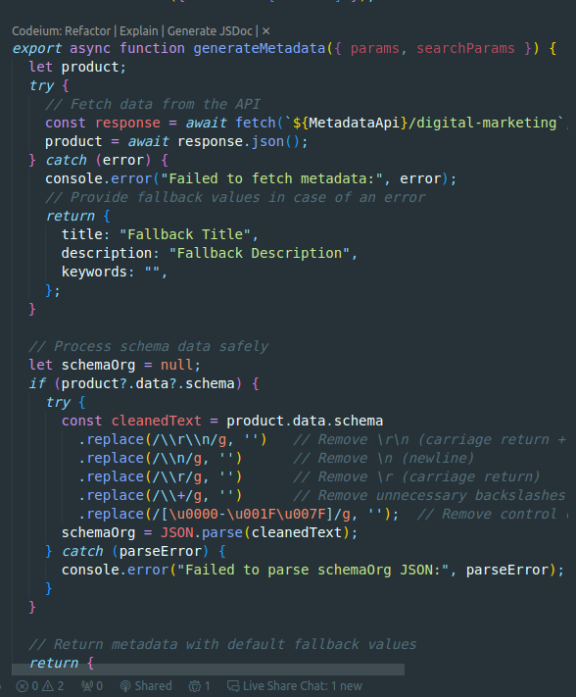
This way, you can print out the error message as well.
Also, to implement the external scripts in nextjs, the process was to add them in a _document.js file or _app.jsfile. These files are the ones which execute initially when the project is run. So any script or css that you want to be applied as soon as your website is opened, you use that in these files. But in nextjs version 14 and above, it is not clear about where to place these files, and no solution is found till date. May be nextjs will add the solution to this in future. But currently, what you can do is, yo can create a separate component where you can add your script in your useeffect and call that component in the main layout file below the body tag. This will execute the file or script as soon as the project is run. Refer to the image attached below.
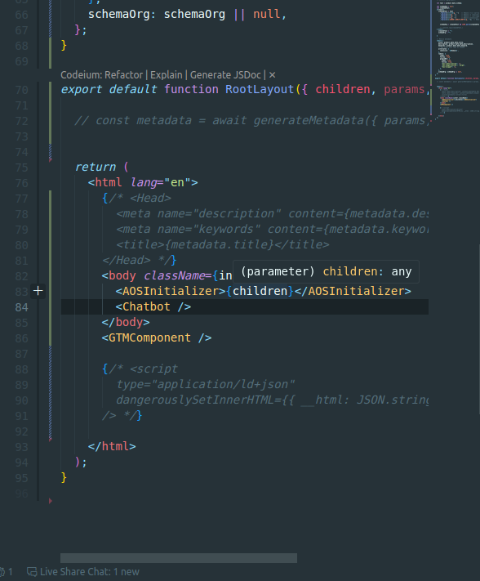
An important point in this is: Make sure the rootlayout function is not asynchronous. This will cause issue in rendering the children pages of the application.

