Payment not working (Jobseeker and Employer)
Jobjeeker
Purchase Membership Plan
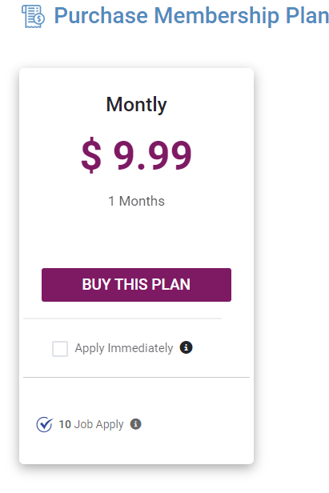

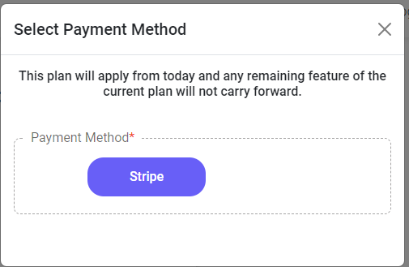

Additionally, during the entry of credit card details, it was noticeable that the form was displayed with German labels but English buttons, even though the set language was English.
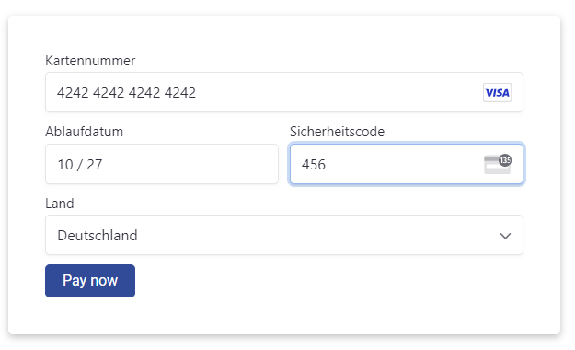

When I click "Pay Now," a few seconds later, the "My Profile" button appears, but no payment is processed. The "My Profile" button does not work either, and it is impossible to exit this form.
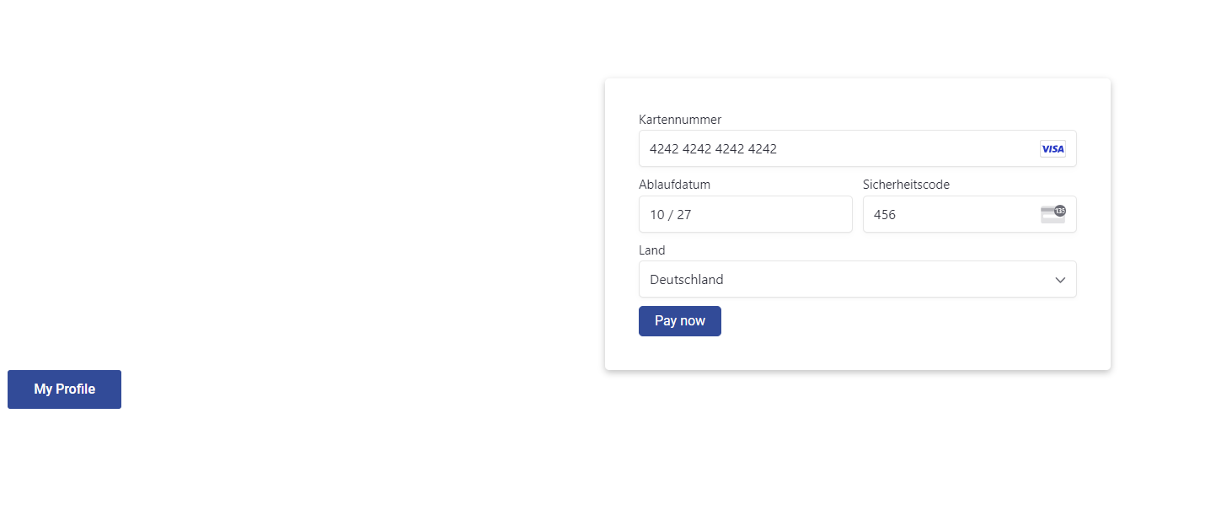

Employer
The "Current Plan" button does not work, so I am unable to test any other pages.

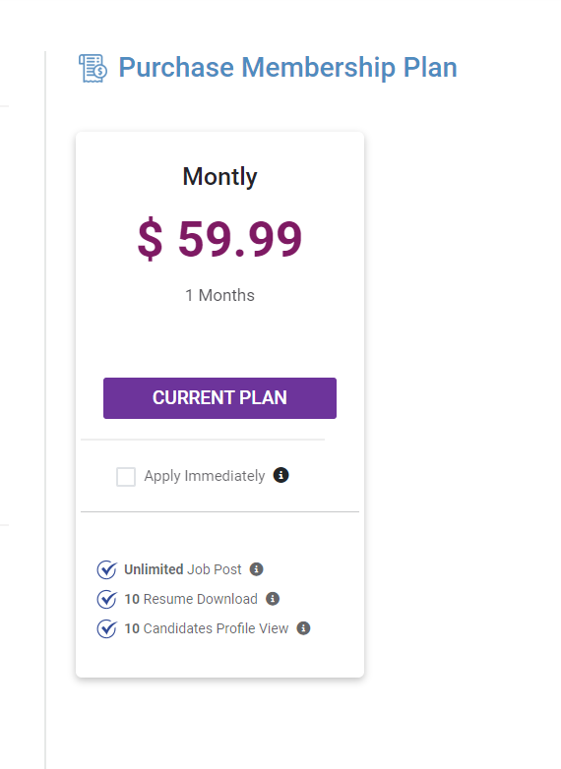

In the "Select Payment Method" section, only Stripe payments are available. It would be very nice if you could also add PayPal as a payment option.

